The easiest way to access the Copyright Clearance Center would be to open the JADA article whose content you wish to reuse. In the upper right-hand corner, you will see a box with a number of options. Please click the “Request Permissions” link as shown below.

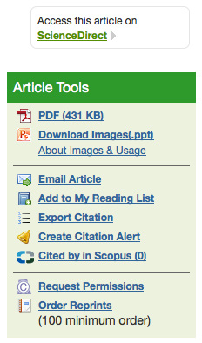

You will be taken to the window below where you can make your selection accordingly from the drop down menu.

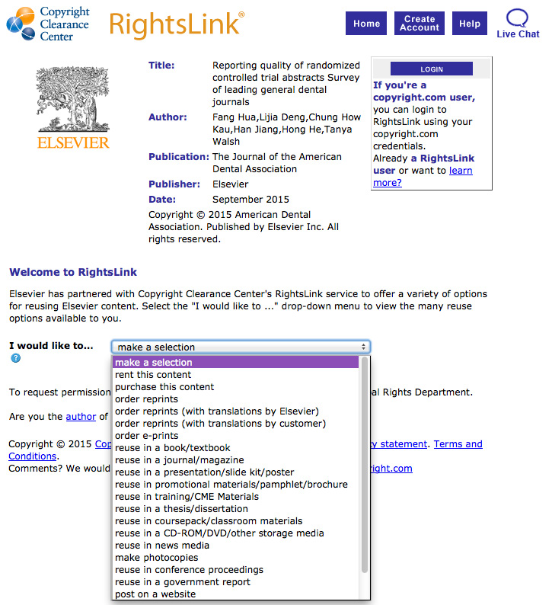

You then will be led through a series of questions, given a quote and can complete your transaction.

Thank you for your interest in and support of The Journal.

